**GAME 3011 - Assignment 4 GDD**

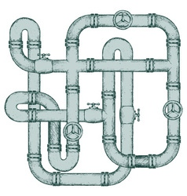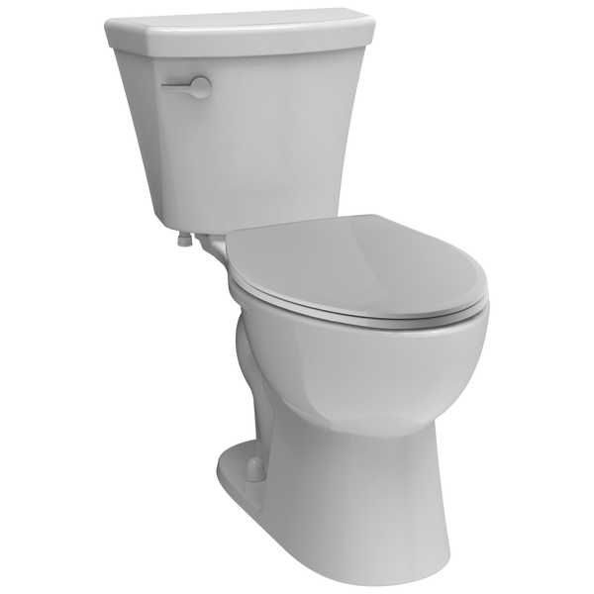

**Game Theme and System**

For this Hacking Minigame Assignment, this will be a Pipe Mania type of hacking minigame. You have to rotate the pipes in their correct position, and make sure that all the pipes connect to one another. You have 30 seconds to complete the pipe puzzle.

**Overall Game System**

At the start of the game you are in a Washroom and you have to fix the toilet. You are brought up with a prompt to press the ‘E’ key to play the game. During gameplay, pipes are rotated at a random angle, some pipes will be at the correct rotation, but it’s unlikely it is. Your goal is to make sure that all the pipes connect to each other at the correct rotation under 30 seconds before the timer goes off. To rotate the pipes, you just have to click on the pipe you want to rotate.

For visuals of the game, there is a 8 by 5 grid with a total of 40 cells on the grid. The pipes in the game have different shapes, like tall, curve, or t-shape. The pipes that can’t get rotated are the cross, start (green), and end (red). You also have a flush button that is like the run button, which will check if all pipes connect properly and will either send you to a win or lose state.

When you match the pipe to its correct rotation, the game system will increment the number of pipes that are in the correct position, and decrement it if you rotate it out of its correct position. During gameplay the game system will count the total number of pipes there are on the grid (minus the start pipe, end pipe, and cross pipe). When you click on the flush button, it will check to see if the number of pipes in the correct position is equal to the total pipes on the grid, if it is you win, if not you lose.

**Levels of Difficulty**

There are 3 levels of difficulty for this mini-game: Easy, Medium, and Hard. Each difficulty has different puzzles. But, for any difficulty of the game, you have 30 seconds to complete the puzzle.

* Easy: less pipe pieces with mostly tall pipes, some curves, few T-shapes and no cross pipes, and has one loop.
* Medium: fair amount of pipe pieces, with mostly curve and T-shape pipes, few tall pipes, no cross pipes, and 3 loops.
* Hard: grid is filled with many different kinds of pipes, 2 cross pipes, and many loops.

**How Skills Affect the Game**

The player’s skills affect the game, because you have to be fast enough to make sure that you have the correct rotation of all pipes, in under 30 seconds. Players can easily be tricked easily by the pipe loops, and the T-shaped pipes, especially in the harder difficulties with more pipes. The Easy level should be solvable, Medium you have to be quicker than usual, and the Hard level, you really have to be fast at solving the puzzle.